Game Design Document

# Project Working Title: Endless Cleaner

# 

# Table of Contents

**Project Working Title: Endless Cleaner** **1**

**Table of Contents** **2**

**Summary** **4**

**Story** **5**

Characters 5

Setting 5

Narrative 5

**Gameplay** **6**

Core Loop 6

Mechanics 6

Dynamics 6

Enemies 6

**Level Design** **7**

Progression 7

Environments 7

Design Bible 7

**Art** **8**

Short Description 8

Art Bible 8

**UI** **9**

Specification 9

**Game Controls** **10**

Specification 10

**Audio** **11**

Description 11

Audio Design Document 11

**Target** **12**

Target Audience 12

Target Device 12

**Analysis** **13**

Market Analysis 13

Tech Analysis 13

Legal Analysis 13

**Analysis** **14**

Market Analysis 14

Tech Analysis 14

Legal Analysis 14

**Game Marketing** **15**

Promotions 15

Community 15

**Development Plan** **16**

SDLC 16

Testing 16

# Summary

An endless runner game where the player is a Character inside the blood vein trying to catch a Virus as the main objective of the game, while collecting Germs as coins, and avoid running through Red Blood Cells or going through a different vein and missing the target Virus, and powering up using White Blood Cells, which will fill up a Special Ability for the player character to use.

Gameplay concept:

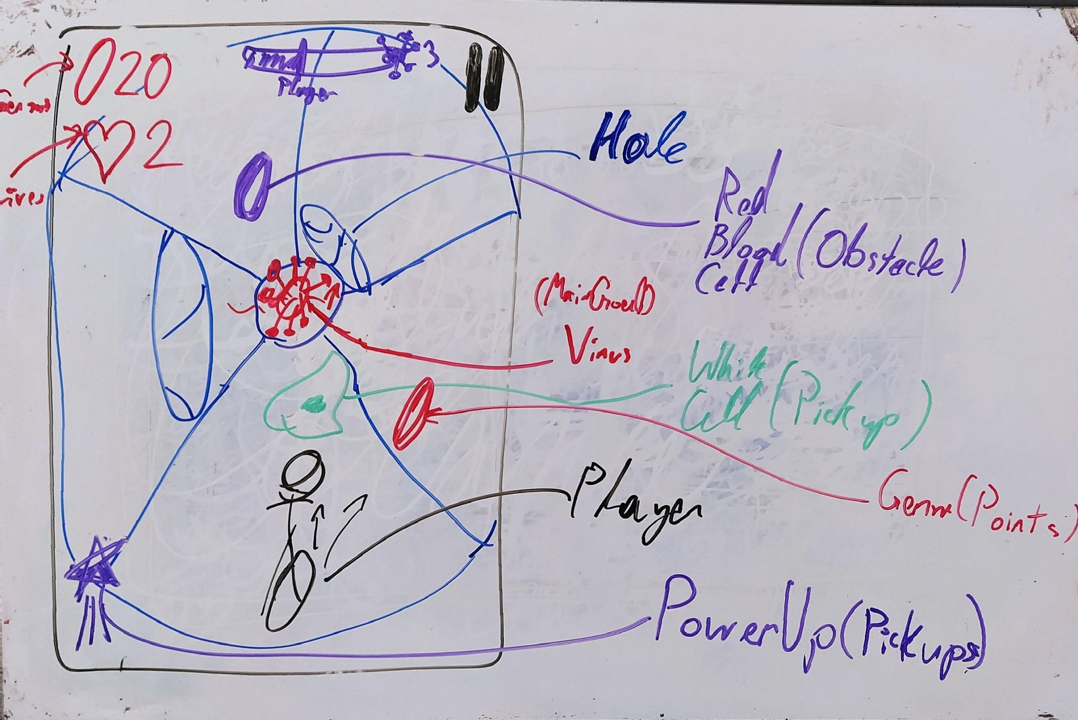

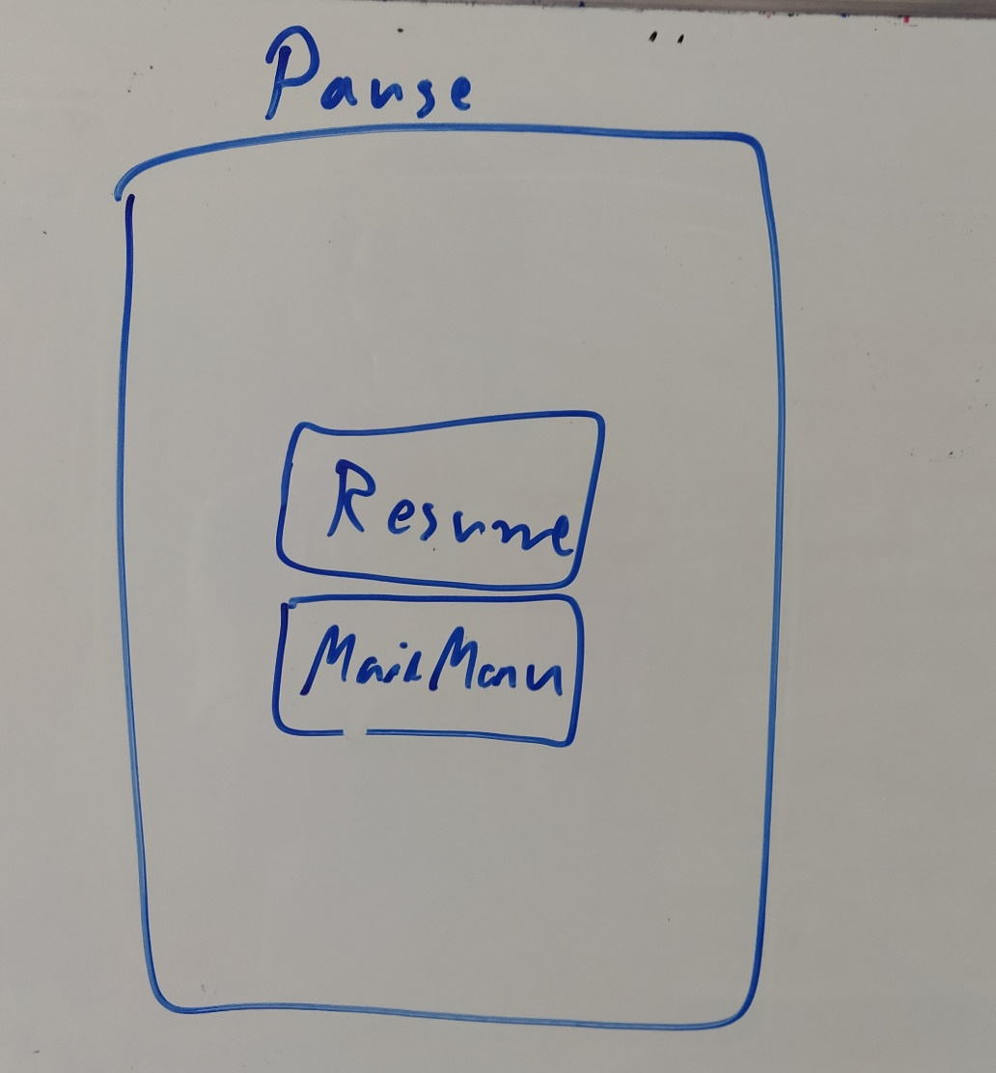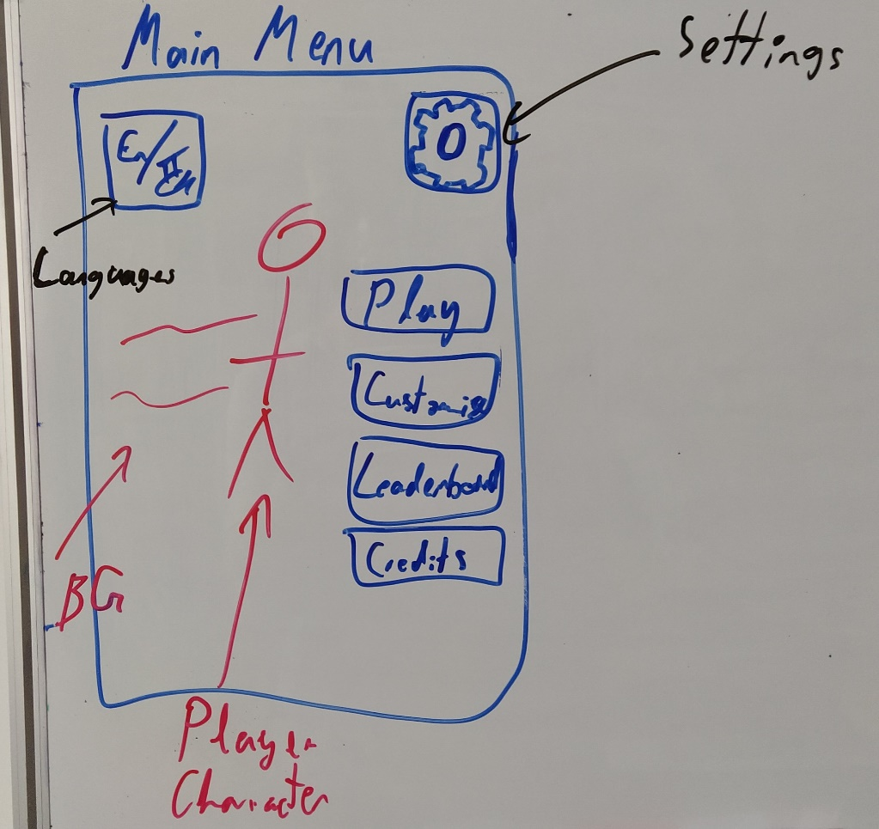

# Story

## Characters

* + 1. Playable Characters:
       1. Karim: The main character, with the special ability as a Super-Speed Dash.
       2. Tala: Kareem’s sister, with the special ability of Slowing Time.
       3. Sami: He has the special ability to pass through obstacles.
    2. Non-Playable Character:
       1. Virus: The main villain character. Can change appearance (different virus types).
       2. Germs: Side villain, collected by the player as coins.
       3. White Blood Cell: Players’ allies, collected as power-ups for the character’s special ability.
       4. Red Blood Cell: Players’ allies, avoided by the player as obstacles.

## Setting

Inside the human blood vein, as a Virus Catcher / Cleaner, and germs, while avoiding obstacles (red blood cells) or going to a different vein, and using white blood cells as power-ups.

## Narrative

None

## 

# Gameplay

## Core Loop

* + 1. Player: The game starts with the player running forward, with accelerating speed until the target enemy is caught.
    2. Virus: The virus moves with an acceleration less than the player, to be able to catch it.
    3. Platform: parts of the blood vessel where the player moves through, while procedurally spawning germs, White Cells, Red Cells and dynamically connect each platform with the next one.
    4. When a Virus is caught, another is spawned.
    5. If the player hits a lot of obstacles and misses the Virus, he will lose a life, the same when the player goes to a different vein.

## Mechanics

* + 1. The player can move the left, right, jump and slide down under obstacles.
    2. The virus is the main objective, and after catching a virus, another one is spawned, and the number of viruses caught is shown in the HUD.
    3. The speed of the player is accelerating through the game (Momentum).
    4. When the player hits a Red Blood Cell (Obstacle) it decreases the speed of the player, which distances the player from the target.
    5. The player can collect Germs as coins.
    6. The player can collect White Blood Cells to fill up his special ability.
    7. Each player character has a unique special ability.
  1. **Restrictions:**
     1. Side movement:
        1. Can Jump, slide, interact with objects.
        2. Can change the direction of the movement.
        3. When the player is grounded, it checks for the next lane.
     2. Forward movement:
        1. The player falls down if he’s on the edge of a gap.

# Level Design

## Progression

* + 1. As the level progresses, the blood vessels become wider, with twists and turns.
    2. When connecting two different types of platforms, the connection should be made dynamically.
    3. The environment is made using parts as platforms.
    4. There are different platform types.
    5. Each platform has several lanes for the player to stick to.

## Platform Types

* + 1. 3 Lane Platform: a platform that has 3 lanes
       1. Normal: No gaps.
       2. One Bridge: Normal with one land connection.
       3. Two Bridges: Normal with two connections.
       4. Small Wide Gap: A big gap in the middle.

## Design Bible

* + 1. Platforms’ types are assigned a probability of selection.
    2. Obstacles can be spawned with an assigned probability of spawn for each platform type
    3. Coins can be spawned with an assigned probability of spawn for each platform type.
    4. Lanes’ positions are assigned in each Platform blueprint.
    5. Platforms’ spawn probability is set in the GameController blueprint.
    6. The probability of each platform’s obstacles and coins are assigned in the platform’s blueprint.
    7. Platforms can rotate according to a probability set in the blueprint of the platform.
    8. If a platform is to be rotated, the lanes’ numbers will have to be adjusted accordingly.
    9. Don’t spawn coins on the initial platforms.

# Art

## Short Description

* + 1. Going for the simplistic cartoonish style for now, but will only use Off-the-shelf assets.

## Art Bible

None.

# UI

## Specification

* + 1. In-game HUD:
       1. Germs (coins) collected counter.
       2. Lives remaining counter.
       3. Distance to target (Virus) meter.
       4. Targets (Viruses) caught counter
       5. Special Ability (Power Up) fillup.
       6. Pause button.
    2. Main Menu:
       1. TBD.

## UI Concept Sketch

## 

# Game Controls

## Specification

* + 1. In-Game Controls:
       1. Move Left - Right: Swipe Left or Right.
       2. Jump: Swipe Up.
       3. Slide: Swipe Down.
       4. Use Special-Ability: Double-tap.
    2. Main Menu:
       1. TBD.

## 

# Audio

## Description

* + 1. TBD.

## Audio Design Document

None.

# Target

## Target Audience

* + 1. Children (-18).
    2. Hyper-Casual Gamers.

## Target Device

* + 1. iOS 9 +.
    2. Android 21+.

# Analysis

## Market Analysis

## Tech Analysis

## Legal Analysis

# Game Marketing

## Promotions

## Community

# Development Plan

## SDLC

* + 1. Using Kanban as the SDLC:
       1. Features.
       2. Bugs.
    2. The boards are available under the Git project.

## Testing

* + 1. Will test on Xiaomi Mi 3 and Android 11 after each major update.